ASSIGNMENT - CRM Lead, Pipeline & Opportunity

Q1: Explain Difference between Lead & Opportunity. How are leads different from opportunities?

Ans - Lead: A lead is an unqualified contact or potential customer. It refers to the initial contact stage where a company has basic information but hasn't yet verified if the person or company is interested in its product or service.

Opportunity: An opportunity arises when a lead is qualified, meaning the prospect has shown interest and a potential deal may exist. It is a more mature stage in the sales funnel, where the chances of closing a sale are higher.

Key Difference: The primary difference is that a lead is a potential prospect that hasn't been qualified yet, while an opportunity is a qualified lead with a higher likelihood of becoming a paying customer.

Q2: Describe the process of creating and sending a quotation.

Ans - 1. Create a Sales Order: In the CRM system navigate to the Sales module, and click "Create" to initiate a new sales order.

2. Add Customer Information: Choose the customer from your list or create a new customer.

3. Add Products/Services: Input the products or services to be quoted, along with the quantities and prices.

4. Set Payment Terms and Conditions: You can define payment terms, delivery details, and other conditions.

5. Generate Quotation: After adding all the required information, generate the quotation by clicking "Save" and "Print" or "Send by Email."

6. Send the Quotation.

Q3: What is rule-based lead assignment in Odoo CRM? Explain any scenario to assign rules and show example with screenshots.

Ans - Rule-based lead assignment allows you to distribute leads automatically to salespeople based on predefined criteria, such as geographic location, product interest, or company size.

Scenario Example:

Company: A company has sales teams for different regions: North, South, East, and West.

Rule: Leads coming from the North region should automatically be assigned to the "North Sales Team," while leads from the South go to the "South Sales Team."

Steps to Assign Rules:

1. Go to the CRM Settings: Enable "Lead Assignment."
2. Define Sales Teams: Create sales teams for each region.
3. Set Assignment Rules: Use filters to define criteria. For example, set the lead's region (North) as the condition.
4. Activate Automatic Assignment: Leads that match the criteria will now automatically be assigned to the respective team.

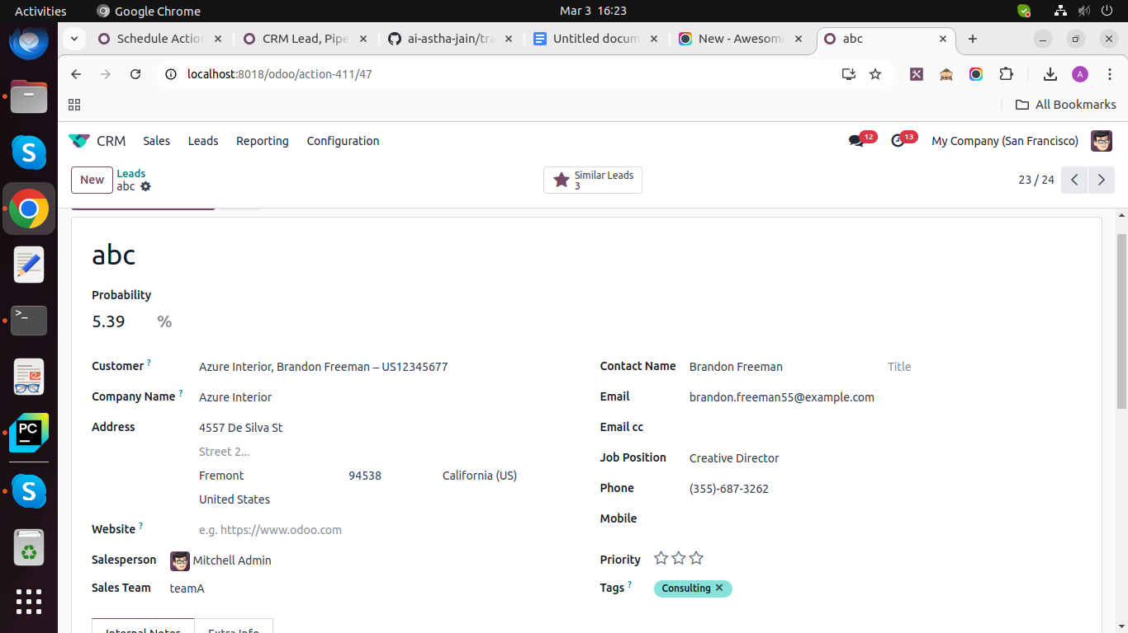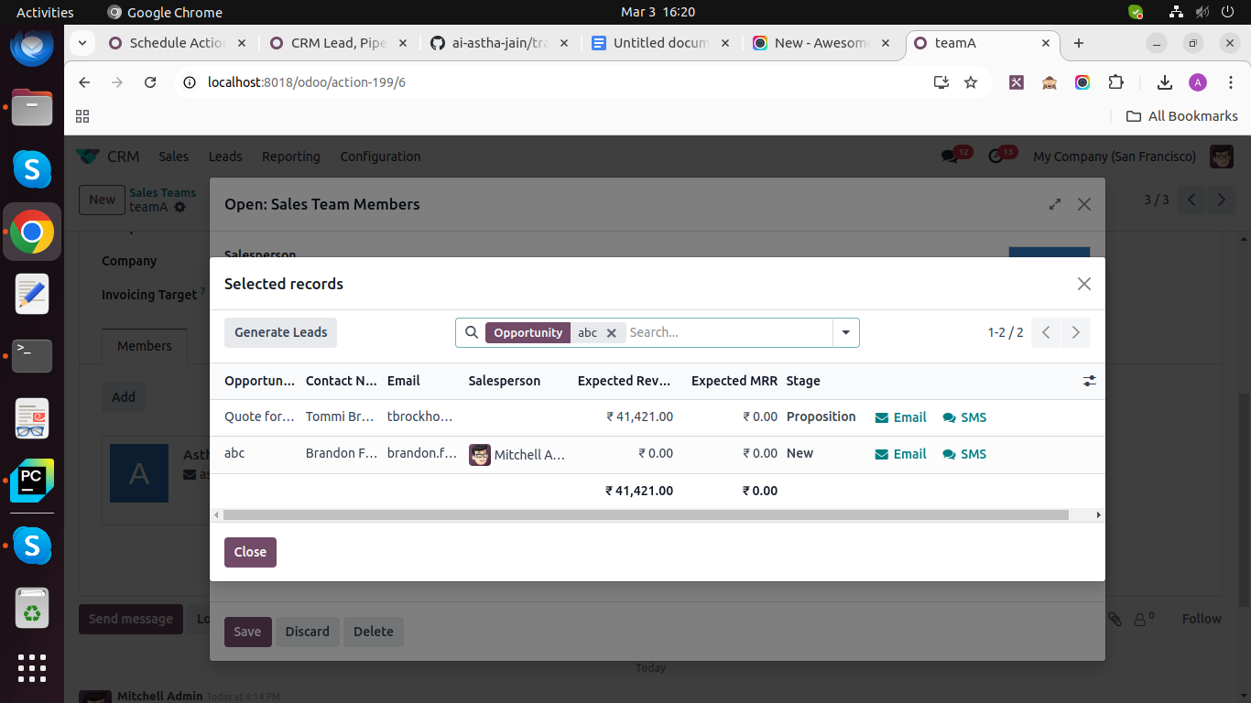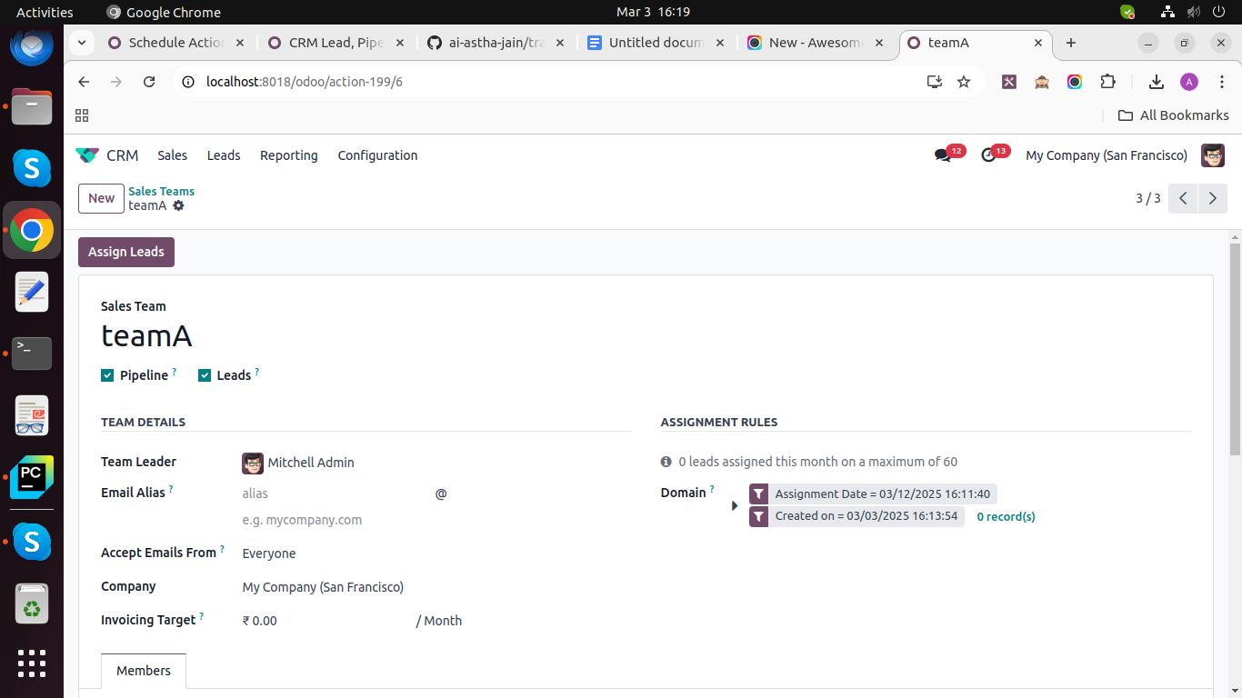

(For better understanding please prefer video attached in training tool.)

Q4: What is the purpose of having multiple sales teams in a CRM system?

Ans - The purpose of having multiple sales teams in a CRM is to improve organization, efficiency, and targeted selling efforts. Some key reasons are:

1. Geographic Specialization: Assign different sales teams to specific regions or territories, enabling them to build local expertise.

2. Product Focus: Assign teams to specialize in different products or services for better knowledge and sales efficiency.

Improved Lead Management: Multiple teams allow more efficient lead assignment and follow-up, preventing bottlenecks in the sales process.

3. Better Performance Tracking: Sales teams can be tracked and managed separately for performance metrics, goal setting, and commission structures.

Q5: Explain the different types of CRM reports available in Odoo.

Ans - Odoo offers several CRM reports that help in analyzing sales performance, customer relationships, and forecasting.

1. Pipeline Analysis Report: This report tracks the progress of leads and opportunities through the sales pipeline, allowing businesses to identify potential deals and bottlenecks.

2. Sales Performance Report: Shows the performance of individual salespersons or teams over a given period, including key metrics like revenue, number of deals closed, and conversion rates.

3. Lead Analysis Report: Offers insights into lead generation and qualification, helping you understand the sources of your leads, the time taken to convert them, and the quality of each source.

4. Activity Report: Displays activities (meetings, calls, emails) performed by sales representatives, helping managers keep track of interactions with customers.

5. Quotation and Sales Order Report: Tracks the number of quotations created, sent, and converted into sales orders, along with revenue and other related metrics.